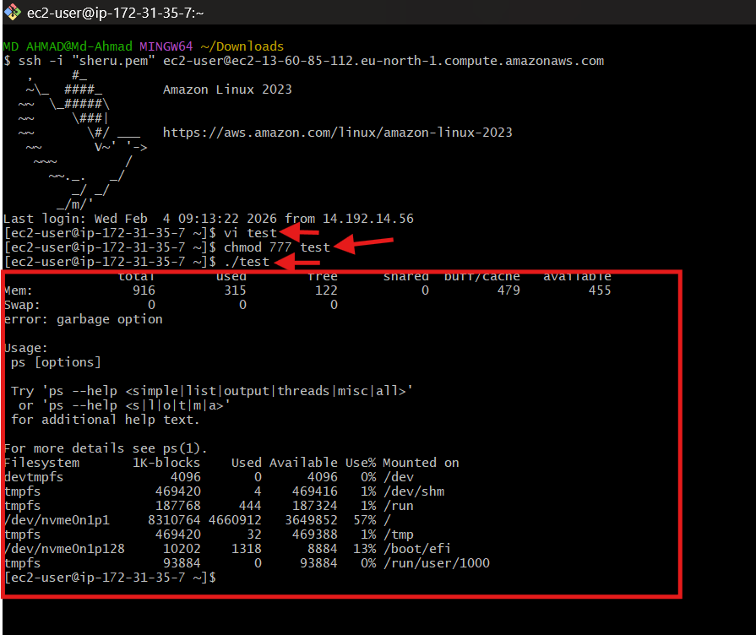
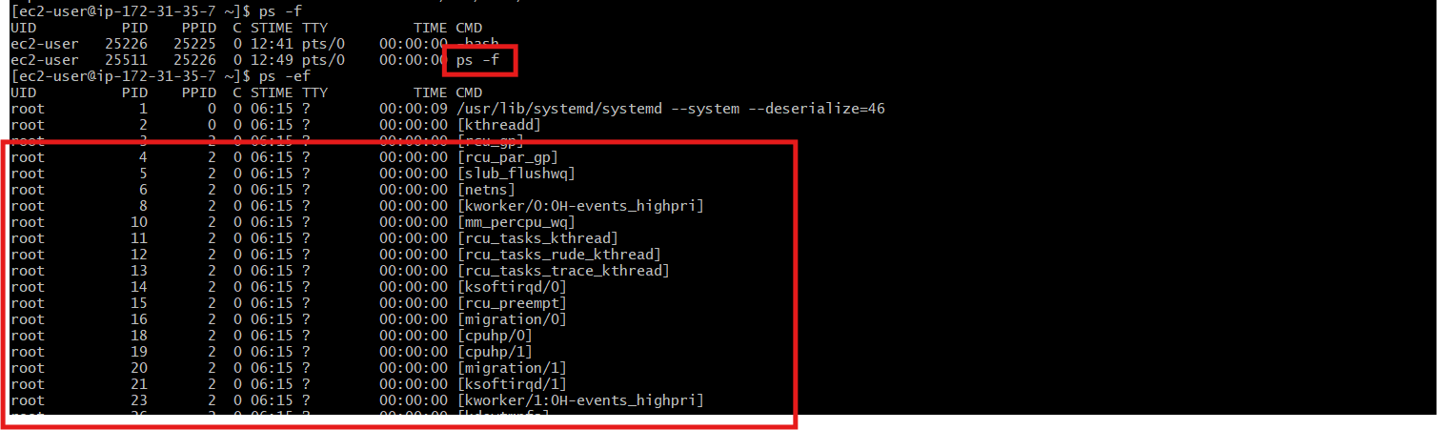
How to find a shell?
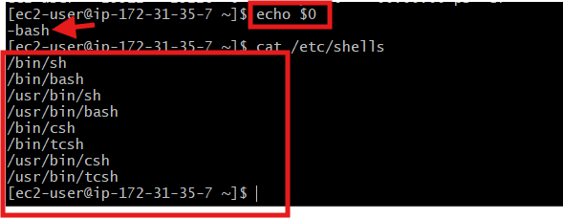

If you want to see that which user is associated with which shell
Command is : cat /etc /passwd
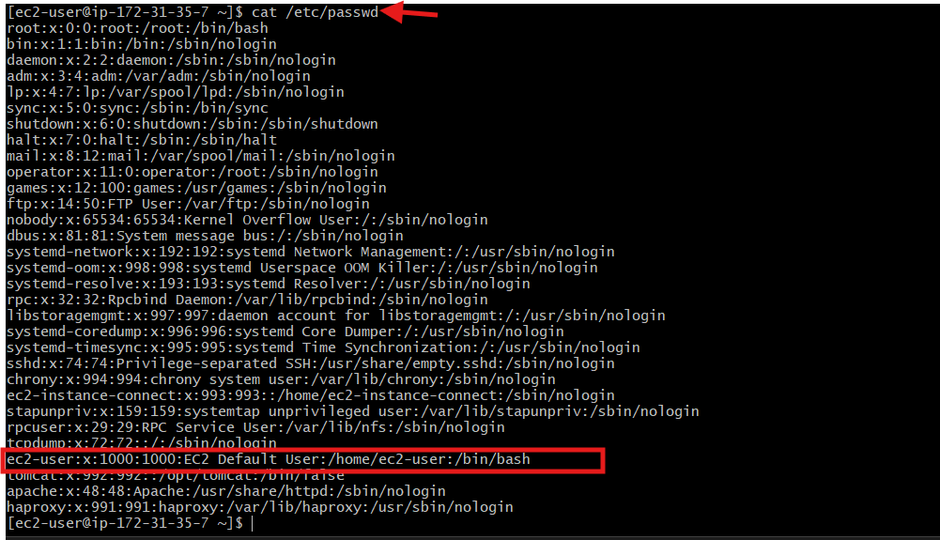

Types of shells :
1 Gnome : Graphical environment in linux ( desktop GOI)
2 KDE : another graphical environment in linux
3 sh : shell ( Bourne of shell developed by unix by Stephen bourne)
4 bash : New features of shell with enchanment
5 csh and tcsh : c shell and tenex c shell advance of version of on c shell

If you want switch to any particular shell ?
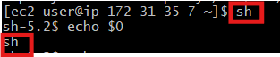
Like this can switch the shell

Hello world Script
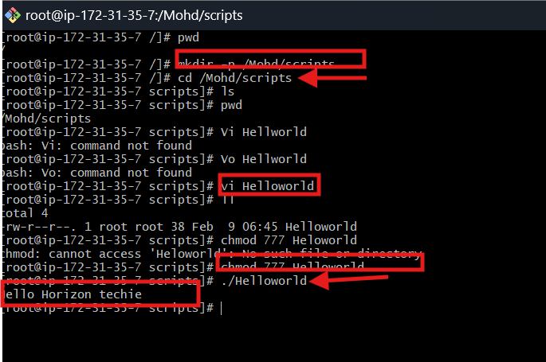

Basic Second script :
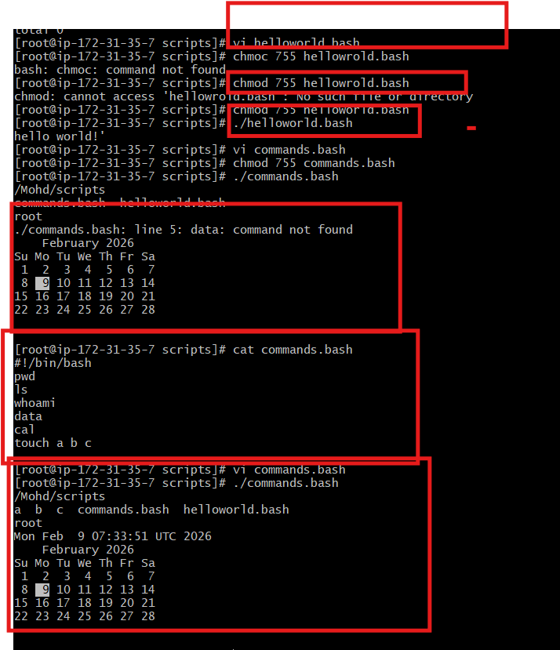

Basic admistrative scripts
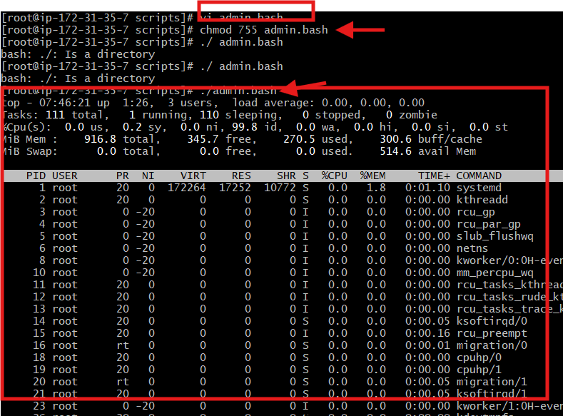
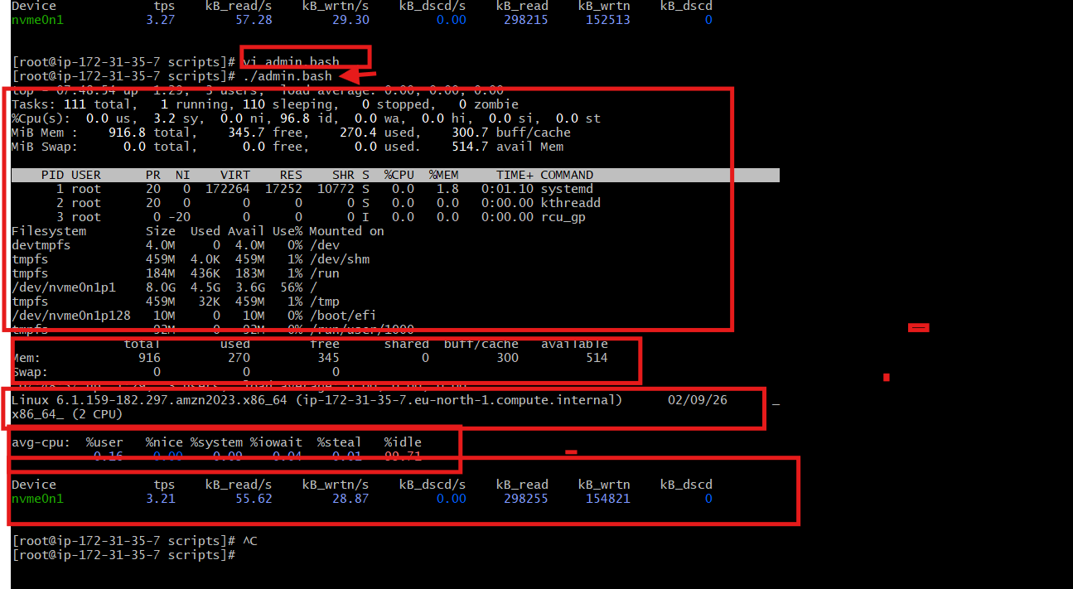

Variable scripts:
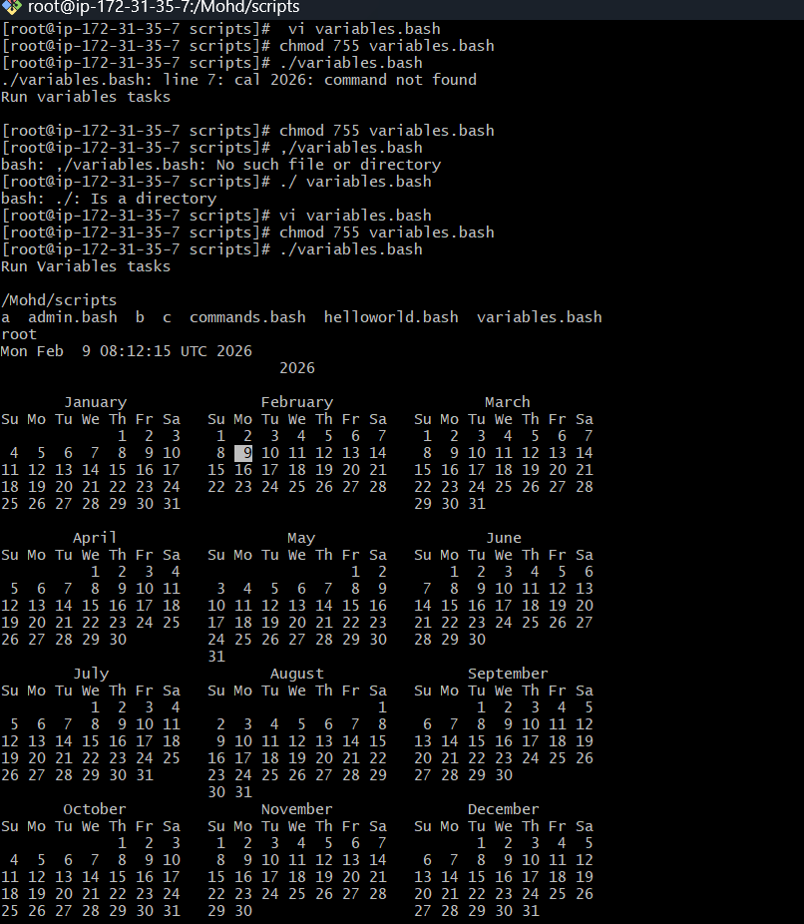
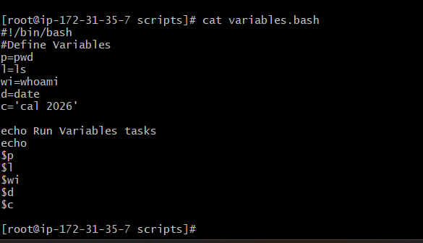

Input scripts:
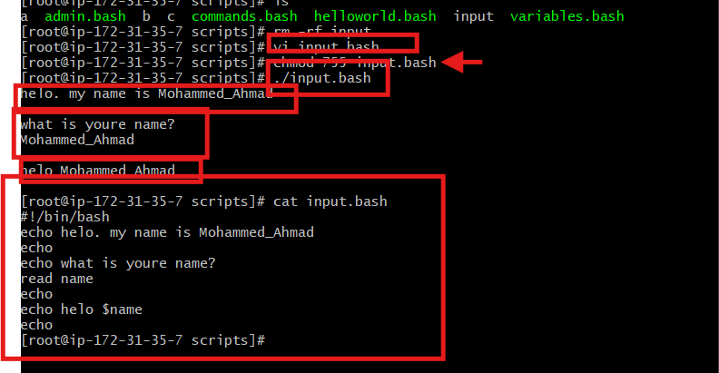

Output scripts:
